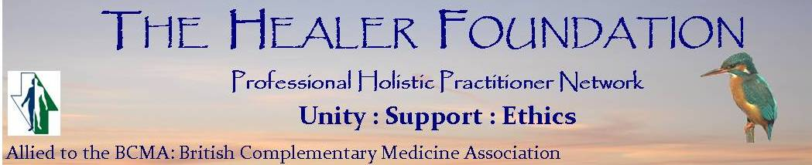

ANNUAL MEMBERSHIP RENEWAL 2025

Annual Membership renewal fees are due by the end of March 2025. Please complete the following renewal form, including details of any amendments/changes together with your insurance certificate and CPD declaration, and return to: office@healerfound.co.uk or Eve Campbell at 5 Willow Park WF1 2JP

Our preferred payment method is by BACS payment direct to The Healer Foundation account at Nat West account no:43832431 sort code:52-30-29 please include your name as the reference so that we can find you on our Bank statement.

Please pay promptly by 1st April – Thank you. This helps our admin and note that the BCMA apply a surcharge of £10 for late payments and we will also apply that surcharge from 2025 of £10 so a total of £20 – you can avoid this addition to your fee by paying by 1st April – Thank you.

NAME:

CONTACT TELEPHONE: ____________________________________________________________________

EMAIL: _____________________________WEBSITE: ______________________________________

PRACTISING NON-PRACTISING 

Note:- Please include a copy of your current professional insurance certificate valid at the 1st April 2025, showing PUBLIC LIABILITY cover.

RENEWAL DETAILS (payment by: BACS please tick) |  |  | Tick as appropriate
ANNUAL SUBSCRIPTION | £80 | This year only. Includes annual membership of BCMA
ANNUAL SUBSCRIPTION | £25 | For non-practising members only, no listing on website

ANY UP TO DATE / AMENDED DETAILS (please print):
Name: _______________________________________________________________________________
Address: _____________________________________________________________________________
_____________________________________________________________________________________
Email:___________________________________ Website:_____________________________________
Home phone: ________________________ Contact Mobile___________________________________
New therapies (you total max is 10) to be accompanied by copies of training certificates: _______________________________________________________________________
_____________________________________________________________________________________

FOR ANY FURTHER QUALIFICATIONS/THERAPIES YOU WISH TO BE ADDED TO WEBSITES, PLEASE ATTACH COPIES OF CERTIFICATES AND UPDATED INSURANCE CERTIFICATE.

CONTINUING PROFESSIONAL DEVELOPMENT RECORDS. Please complete this form and send with your renewal.
The Healer Foundation and the BCMA require that a minimum of 20 hours CPD is completed each year from a minimum of 2 categories. The listing is for guidance; if you have participated in something that has been of value to you, please include it. Please call Eve on 07803 939431 if you are unclear about your CPD requirement and activity.

Name: ________________________________________________ Year ending: 31st March 2026

CPD activity undertaken | Category  (see below ) | Number of hours
1.

2.

3.

4.

5.

6.

I confirm that I have carried out the above CPD activities in the last 12 months and am able to produce proof as required by the BCMA if requested. (It is NOT necessary to supply receipts with this form)

Your Signature: _______________________________________________________________ Date: ________________________________

Categories
Two categories at least should be chosen, taking at least 20 hours over any one year.
These activities are for guidance and are not set in stone. If you have participated in something which has been of value to you, please document it.
Category 1: Short courses on professional issues
eg Courses undertaken in areas of special interest relevant to your work or expanding your way of thinking, or deepening your understanding of a related subject. Could be evening talks, one-day event or a weekend.
Category 2: Meetings, seminars, conferences, AGMs
eg Organised locally, nationally, internationally, Health Shows.
Category 3: Study for further qualifications
eg Advanced Diploma Courses. Certificated Courses.
Category 4: Encouraging the development of others
eg Running a workshop. Giving a talk at a conference/meeting. Writing a book review. Writing an article. Organising a peer group for sharing/discussion. Giving some time to listen to another practitioner who may have a difficulty. Producing a newsletter.
Category 5: Active committee work for a professional body related to your work
eg Being a secretary. Being on a working party. Helping at a Conference.
Category 6: Personal/professional Development
Personal therapy (psychotherapy, counselling, physical therapy). Time and space given for personal reflection – this needs to be properly documented. Talking with another professional to gain some insight – this needs proper documentation. Having supervision. Doing a piece of study/reading for personal insight. Attending a sports event and offering massage. Giving a talk/presentation at a sports club or the WI etc about your work.
Category 7: Journals and IT
Reading professional journals. Use of internet to access professional information related to work/clients. Doing a piece of research. Watching a video/film for educational purposes relevant to professional life. Using library facilities for the development of learning. Learning computer use. Making a web site.
Category 8: Formal training
Where a formal training course in excess of 50 hours has been taken in a year, you may request the CPD coordinator for a variation in the subsequent year’s CPD requirement in terms of time and appropriate activities to maintain compliance with requirements. Any variation agreed would be in writing and at the discretion of the CPD coordinator and/or Executive Committee.

